
Department | FED
Subject | DSA-2
Academic Year | I-III Semester (2025-26)
Faculty Name | Md.Razia
Student Name | Kolla Swathi Sree
Roll Number | 2520030410
Branch | CSE
Course Outcome | CO2

Case Study Topic: MongoDB Compound Index using B+ Tree on (user_id, timestamp)
Work Done Summary:

In this case study, we analyzed how MongoDB uses a composite B+ Tree index on the fields (user_id, timestamp). The objective was to determine whether different query types can efficiently utilize the compound index and to estimate the cost of a query involving an exact user_id match and a timestamp range.
The study also examined why MongoDB may avoid using the compound index for queries that only specify the timestamp field without the prefix field user_id.

Implementation Details:
- Considered a MongoDB collection indexed on (user_id, timestamp).
- Analyzed three query patterns:
- user_id = 42 AND timestamp range
- user_id = 42
- timestamp only
- Applied the B+ Tree prefix rule to determine index usability.
- Estimated B+ Tree height for approximately 2 × 10⁹ entries.
- Calculated the page reads required for the range query.
- Studied why suffix-only queries are inefficient.
- Concluded that prefix fields must be included for effective index utilization.
Result: Screenshots / Output
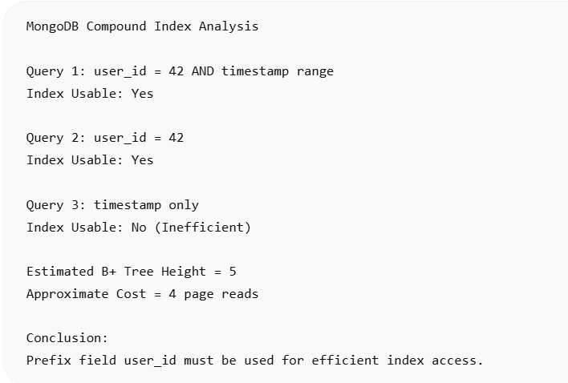

Composite Index Usage
Query Type | Index Usable? | Reason
user_id = 42 AND timestamp range | Yes | Uses prefix field user_id and range on timestamp
user_id = 42 | Yes | Index is sorted by user_id first
timestamp only | No (Inefficient) | Timestamp values are spread across all users
Cost Estimation
For:
user_id = 42
timestamp BETWEEN '2024-01-01' AND '2024-01-31'
Total entries:2 × 10^9
B+ Tree Height: log100(2 × 10^9) ≈ 5
Assuming top 3 levels are cached: 5 − 3 = 2 page reads
Additional leaf-page scans: 1–2 page reads
Total Cost: ≈ 3–4 page reads
Why Timestamp-only Queries are Avoided
Index order: (user_id, timestamp)
Without specifying user_id, MongoDB cannot directly locate matching timestamps.
Therefore:
- Efficient prefix search is not possible.
- Large portions of the index must be scanned.
- Query optimizer may choose a collection scan instead.
Conclusion:
The compound B+ Tree index (user_id, timestamp) efficiently supports queries that include the prefix field user_id. Queries using both user_id and timestamp range require only a few page reads and provide excellent performance.
However, queries that use only timestamp cannot efficiently utilize the index because the leading field is missing. Therefore, MongoDB may avoid the index and perform a scan instead.

GITHUB LINK : https://github.com/Swakshaya/Case-Study-Project

Student Signature | Faculty Signature

